***North South University***

***Course: CSE327***

***Section:06***

***Groupmates:***

* *Mohsin Kamal - 1721309642*
* *Shaiqa Sharmeen - 1711713042*
* *Shahariar Sakib - 1712965642*
* *Tasfia Nausheen - 1711488042*

**Table of Contents**

|  |  |
| --- | --- |
| Project Proposal | **4** |
| **1. Introduction!** | **5** |
| * 1. Purpose! | 5 |
| 1.2. Scope! | 5 |
| 1.4. References! | 5 |
| 1.5. Overview! | 5 |
| **2.Stakeholders** | 6 |
| **3.Requirements Elicitation Technique** | 6 |
| **4.Overall Description!** | **7** |
| 4.1. Product Perspective! | 7 |
| 4.2. Product Functions! | 7 |
| 4.2.1. Account Registration! | 7 |
| 4.2.2. Account Login! | 7 |
| 4.2.3. Forgot password | 7 |
| 4.2.4. Accident! | 8 |
| 4.2.5. Driver! | 8 |
| 4.2.6. Vehicle! | 8 |
| 4.2.7. Location! | 8 |
| 4.2.8. Notification! | 8 |
| 4.3. User Characteristics! | 8 |
| 4.4. Constraints! | 8 |
| 4.5. Assumptions and Dependencies! | 8 |
| 4.6. Apportioning of Requirements! | 9 |
| 4.7. Context Diagram | 9 |
| **5. Specific Requirements!** | **9** |
| 5.1. External Interface Requirements! | 9 |
| 5.1.1. User Interfaces | 9 |
| 5.1.2. Hardware Interfaces | 10 |
| 5.1.3. Software Interfaces | 10 |
| 5.1.4. Communication Interfaces | 10 |
| 5.2. Functional Requirements! | 10 |
| 5.2.1. Stimulus: Click "Register" Button: Account Registration! | 10 |
| 5.2.2. Stimulus: Click "Login” Button: Account Login | 10 |
| 5.2.3. Stimulus: Click "accident” Button: accident | 11 |
| 5.2.4. Stimulus: Click "Location" Button: location | 11 |
| 5.2.5. Stimulus: Click "Driver” Button: Driver | 11 |
| 5.2.6. Stimulus: Click "vehicle” Button: Vehicle | 12 |
| 5.2.5. Stimulus: Click "Notification” Button: Notification | 12 |
| 5.2.6. Stimulus: Click "Logout" Button: Account Logout | 12 |
| 5.3. Non-Functional Requirements | 12 |
| 5.3.1. Performance Requirements | 12 |
| 5.3.2. Reliability! | 12 |
| 5.3.3. Availability! | 12 |
| 5.3.4. Security! | 12 |
| 5.3.5. Maintainability! | 13 |
| 5.3.6. Portability! | 12 |
| 5.4. Logical Structure of Data | 13 |
| 5.4.1. Types of Information used | 13 |
| 5.5. Design Constrains | 13 |

**Software Requirements Specifications (SRS)**

**Project Proposal**

**Project Title: Road accident data record**

**Introduction:** In Bangladesh, there are a number of road accident happened daily. But there is no software base application where police can record these accident data. Police recorded these data manually filling a road accident record form and there is a risk of lost those data or very hard to find recorded data from record file that previously recorded. It will be easy for them if they record these accident data and search the data via software. It’s also efficient for time and security.

**Our Features with description:**

**Technical Features: -**

* Sign up: There will be sign up window for the police, admin (high ranked police) and user (journalist). Police will be able to see and insert some details that are signed up. Admin has to sign up but they will have a code which is needed to log in. User sign will able to see only few data only.
* Login: People logged in to our software will be served with all our features.
* Admin panel and easy data insertion: There will be an admin panel. All major changes must be done by the Administrator. We shall keep an access through which admin will be able to manage data from software. They will not need to bring changes in the code. So, data will be inserted easily.
* Users Access restriction: Users will not be allowed to insert any data or change recorded data.
* Notification: Admin get a notification if police insert any information and users search any data.
* User feedback: Users have the freedom to send us the feedback.

**User Level Features:**

* Research: police can research what is the main reason for accident in a particular road.
* View record : user can view previous years accident record.
* Notification: admin able to know who insert data and view the data.

**Languages and Framework: -**

* C#
* Visual studio
* Asp.net
* jQuery
* MS sql server

Front-end framework

* GUI

Back-end framework

* C#

**Conclusion:** This is a project to develop an idea to ease the difficulties of record road accident data. Our belief is that one handy pc software application will make a huge change in this sector. A steady, sustained and ongoing development of this application may achieve more user value in future.

**1. Introduction**

**1.1. Purpose**The purpose of this Software Requirements Specifications (SRS) is to fully document the specifications and requirements for the Road accident. Here is all the specification that we will be implementing in our application. The audience of this SRS will be the clients who want the software to be built and the technical professionals developing the software.

**1.2. Scope**The objective of this project is to create and implement an application for the police and user. The application will be used primarily by police from all over the country. The application will allow police to create and maintain individual secured accounts. Police around country can easily record data and get all the information about the any accident.

**1.4. References**The following material was used in creating this document:  
• IEEE Std 830-1998, IEEE Recommended Practice for Software Requirements Specifications.

**1.5. Overview**The rest of the SRS is organized as follows:

* Stakeholders
* Requirement elicitation techniques
* Section 2 is an overall description of the project.
* Section 3 cites the specific requirements

1. **Stakeholders: -**

* Police with specific thana can find out the main reason of accident in his area;
* Journalist;
* Researcher;
* Government consultant;
* Vehicle owner ;
* Local populations

1. **Requirements Elicitation Techniques: -**

**Questionnaires: -**

1. **Do you think a secured admin panel is necessary?**

**Ans:** Yes obviously. Because I do not want to show my personal info in public. Also, I want to show that info which I like. But there is some other information I want to keep it private. So, security reason is necessary, I think.

1. **Do You want to be a registered user of this application?**

**Ans:** Yes. I want to be a registered user of this application because this road accident registration form for police and user that they can easily register them.

1. **Do you expect any login panel in this software?**

**Ans:** Yeah i want. I want my every information to be secured in this software also.

* **Brainstorming: -**

We have to think about the policies like national police security policy cause without maintaining those policy we can't launch our application.

* **Observation: -**

**Analysis of Existing System: -** We have to analysis the functionality of existing application to build a unique application.

**4. Overall Description**

**4.1. Product Perspective**This product is an entirely new product. It is not a component of a larger system. The Road Accident, this system will interact with Police Management in order to record road accident from the road accident. The system will also interact with the accident record’s database, which records the quantity of accident happen in across the country. The application will also show the record happened in previous year. It will hold record of police info and witness of accident. It also holds the record of driver and passenger information. It will also have a notification system.

**4.2. Product Functions**The following list of function descriptions explains the major features of our Road Accident Record Application.

**4.2.1. Account Registration  
The registration function shall allow users to create secure accounts.**

The account will track the name, address, rank, username, and password for police and user.

The account will track the name , address , rank, verify code, username and password for admin.

*Rationale:* This provides security to the account member by setting up an account that is password protected. This also offers convenience so the admin, police, user only has to enter the information listed above once and then it is stored in the account.

**4.2.2. Account Login  
The account login function shall allow account members to enter  
their username and password.** Once verified, users will be able to access account history, and update their account information.  
*Rationale:* This provides a method by which the user can access the restricted operations.

**4.2.3. Forgot Password   
This function will allow to change the password if the user forgets it.** It will ask some question regarding their information and if all the information matches then the user will have access to change the password.

**4.2.4. Accident  
The accident function hold record of passenger** **collided vehicle number, passenger number,** **accidental vehicle #,wounded number of driver, wounded number of passenger, date of accident, reporting time and date, Type of accident, Weather on accident day, Traffic control system, Type of road**

*Rationale*: This offers convenience to the user by allowing them to make sure a booking is placed for hotel or guides.

**4.2.5. Driver  
The driver function hold the recode of driver name, id, license, accident location, and accident id**  
*Rationale:* This helps the user to insert of driver info and view info.

**4.2.6. Vehicle  
The vehicle function hold the record of vehicle id, owner name and address, type of vehicle, and speed of vehicle.***Rationale:* this helps the police to insert the accidental vehicles information.

**4.2.7. Location**

**The location function holds the record of accident spot nearest of a Thana.**

*Rational:* this helps the police to hold the record of accident spot.

**4.2.8. Notification**

**The notification function helps the admin to know who view the data and insert the data**

*Rational:* this will help admin able to know who insert data and make him aware about accident.

**4.2.8. Account Logout  
The account logout function shall allow account members to exit their account for security purposes.***Rationale:* This allows account members to exit their accounts, and prevent others from accessing it.

**4.3. User Characteristics**Users of the application must know how to navigate in a software and insert data in record box.

**4.4. Constraints**The constraints on the services and functions of the system are as follows.  
• The software product must confirm to national police code of conduct policy.

**4.5. Assumptions and Dependencies**Since the Tourism guideline website is only accessible through the Internet, it is assumed that the end user has a connection to the Internet. It is also assumed that the user has a web browser able to display the website. (I.E. Microsoft Internet Explorer 4+ or compatible browser)

**4.6. Apportioning of Requirements**There are no requirements that may be delayed until future versions of the system.

**4.7. Context Diagram**

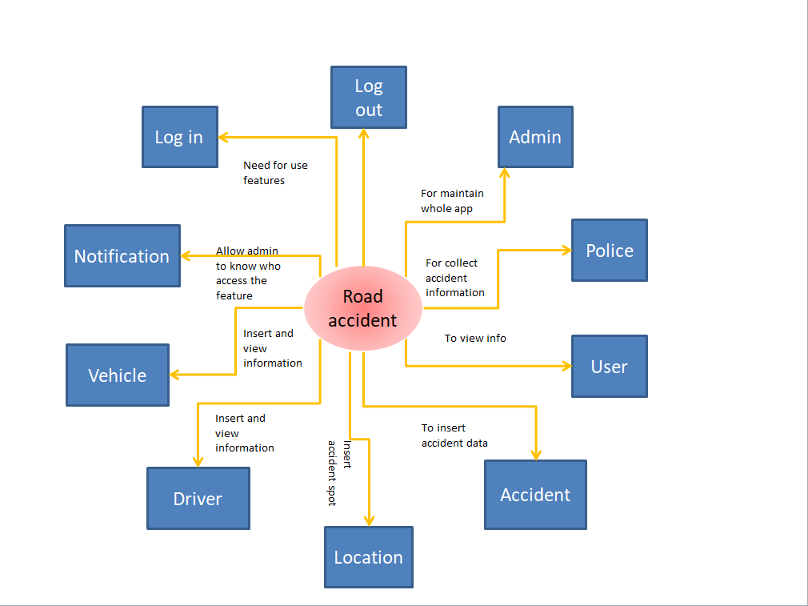

**5. Specification Requirements**

**5.1. External Interface Requirements**

**5.1.1. User Interfaces**The system will provide the ability for police to access the application via offline. There will be three different user interfaces that will accompany this website: one for the user, one for police, and the administrators.  
• User will not be allowed to search database without having to login, however, they must login in order to perform any other queries.  
• Administrators will be required to login at all times. However, they will have all the access via the app-interface. They can update app application data through the app.

**5.1.2. Hardware Interfaces**There are no special hardware interface requirements.

**5.1.3. Software Interfaces**The app will be using one of the most popular framework GUI and C#. Through these frameworks the app will be designed and other features will be given.

**5.1.4. Communication Interfaces**There are no special communication interfaces requirements.

**5.2. Functional Requirements**

**5.2.1. Stimulus: Click "Register" Button: Account Registration**

**As a** user

**I want** to register my account

**So that** I can log in

**Confirmation / Acceptance**1. The system shall allow a non-registered user to create a secure account.  
2. The system shall require the following information from the user: Name, Email, and Username Password.  
3. The system shall ask the user for a username and password.  
4. The system shall confirm the username and password are acceptable.  
5. The system shall store the information in the database.

**5.2.2. Stimulus: Click "Accident" Button: Accident type – 1**

**As a** user

**I want** to insert accident record

**So that** I can view accident data

**Confirmation / Acceptance**1. The system shall allow a registered and logged-in user to insert information and view information.  
2. The user must enter a vehicle number, passenger number, Collided vehicle number, passenger number, Input of accident #, accidental vehicle #,wounded number of driver, wounded number of passenger, date of accident, reporting time and date, Type of accident, Weather on accident day, Traffic control system, and Type of road .

**5.2.3. Stimulus: Click "Driver" Button: Driver**

**As a user**

**I want** to insert driver’s information

**So that** I can see information

1. The system shall allow a user to insert driver record.  
2. The system shall allow a user to view accident no, location, driver information.

**5.2.4. Stimulus: Click “Location" Button: Location**

**As a user**

**I want** to insert location information

**So that** I can see information

1. The system shall allow a user to insert accident location information.   
2. The user shall be able to view the accident information.

3. Only nearest Thana can insert information

**5.2.5. Stimulus: click “Vehicle” Button: Vehicle**

**As a user**

**I want** to insert vehicle’s information

**So that** I can view information

1. The system shall allow a user to insert vehicle information

2. the system shall allow a user to view vehicle info, accident no.

**5.2.6. Stimulus: click notification “Notification” Button: Notification**

**As a user**

**I want** see information who view accident information

**So that** I can identify viewer.

1. The system shall allow admin to see viewer’s information who tries to get information.

**5.3. Non-Functional Requirements**

**5.3.1. Performance Requirements**The performance requirements are as follows:  
• System login/logout shall take less than 5 seconds.  
• Orders shall be processed within 10 seconds.

• System shall support 10,000 simultaneous users.

**5.3.2. Reliability**The average time to failure shall be 30 days. In the event that a server does crash, a backup server will be up and running within the hour.

**5.3.3. Availability**The application shall be available to users 24 hours a day, 7 days a week, with the exception of being down for maintenance no more than one hour a week. If the system crashes, it should be back up within one hour.

**5.3.4 Security**Users will be able to access only their own personal information and not that of other users. Data record will be handled through a secure server to ensure the protection of user’s personal information.

**5.3.5. Maintainability**Any updates or defect fixes shall be able to be made on server-side computers only without any patches required by the user.

**5.3.6. Portability**Nothing required

**5.4. Logical Structure of the Data**The two sections below show the different types of information used by various functions and the overall data model, respectively.

**5.4.1. Types of Information used**The types of information used by various functions of the website:

|  |  |
| --- | --- |
| **Function** | **Types of Information Used** |
| Account Registration | User information (name, email, number, and user name, and password) |
| Account login | User information (user name, and password) |
| Notification | Show information (name, email, number, and user name). |
| Accident | User information (vehicle number, passenger number, Collided vehicle number, passenger number, Input of accident #, accidental vehicle #,wounded number of driver, wounded number of passenger, date of accident, reporting time and date, Type of accident, Weather on accident day, Traffic control system, and Type of road). |
| Driver | User information (driver id, driver name , driver license, expired date of driver license, gender of driver , driver age, condition of driver ). |
| Location | User information( location name, Thana name, distance from Thana) |
| Vehicle | accident id, vehicle id, owner name and address, vehicle type (bus, truck, car etc) , and vehicle speed. |

**5.5. Design Constraints**The road accident shall conform to the following design constraints:  
• Able to support PC, Mac.  
• System supports all browsers (i.e. graphical, non-graphical).